**Decision surface for k-NN as k changes:**

Decision surface is the surface drawn in between dataset which seperated different classes of the training data.

Now we’ll see how decision surface changes when k changes.

For dataset in below image we can draw 2 different decision surface without any calculation.

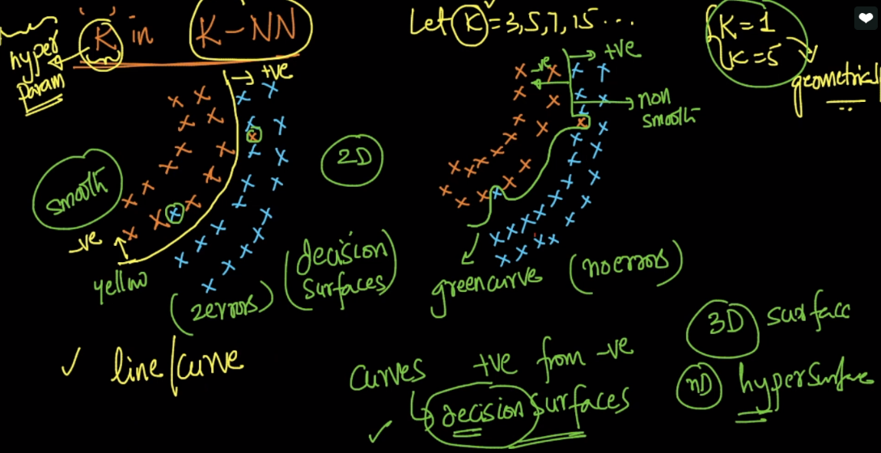

Now let’s see what if we choose k = 1.

As we can see we’ll try xq at different position and assign the class according to the nearest one data point’s class, so for k=1 we get non-smooth curve or jagged curve.

Now for k=5.

Again we do same process, and get’s smooth curve because, it’s not consider the exception where one class point’s come in other’s class’s region as majority vote will favour that class whose region is there.

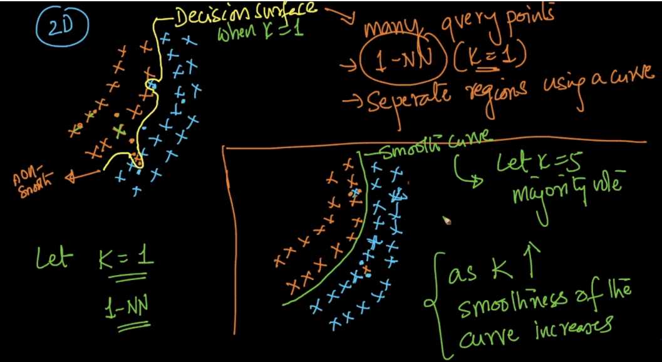

Now let’s say we have total **n** points, where **n1**  are +ve, **n2** are –ve.

And if we choose k=n.

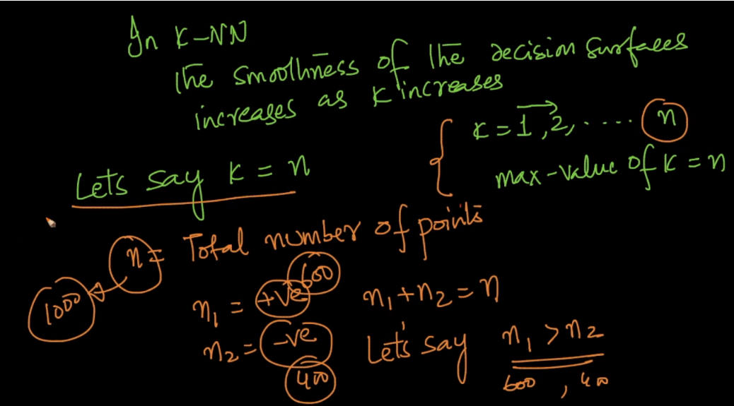

Let’s k = n = 1000, n1 = 600, n2 = 400.

Since n1 which is +Ve have more no of points than n2 which is –ve.

And we have k = n, that mean we’ll take majority Vote with all the n points, so no matter where you place the query point, it will always gives the result as +Ve, because no of +Ve are more than no of –ve.

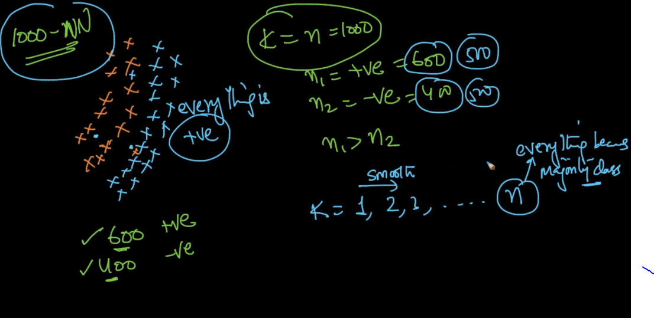

We can say as k increases smoothness of curve also increases.

Comments:

Is there any way to choose an optimal value for k or this is just an iterative method and we will come to know after performing every time with some value of K ?

The optimal value of 'K' is found using Hyper-parameter tuning. We need to train the model using the train data for different values of 'K' and we have to compute cross validation score everytime. Whichever value of 'K' yields the best cross validation score, that is considered to be the optimal value of 'K'.